Hair Color Dispenser - Connection scheme

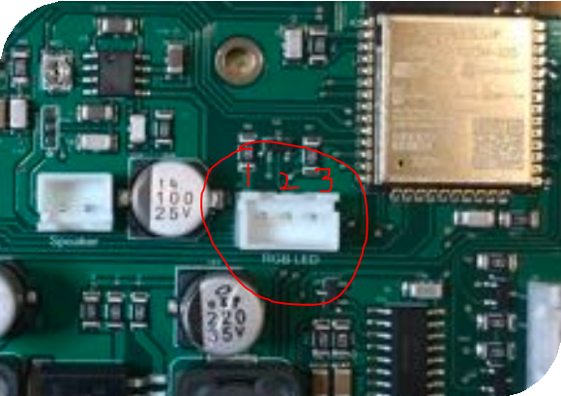RBG LED
Figure 1: Header for RGB LED:

RGB LED
Pin 1: Red
Pin 2: GREEN (YES)
Pin 3: WHITE

  - 3-pin header in the middle of the board, next to 100uF cap, is for RGB LED strpi. The LED connector has 3 wires; RED, BLUE and WHITE. Place the connector on header such that the RED wire sits above pin 1 of the header. NOTE. THE RGB LED STIP HAS RED, GREEN AND WHITE NOT (RED BLUE AND WHITE). ARE THE BLUE AND GREEN WIRES THE SAME?
Yes, in this scenario, the GREEN is substituted with BLUE.

SPEAKER

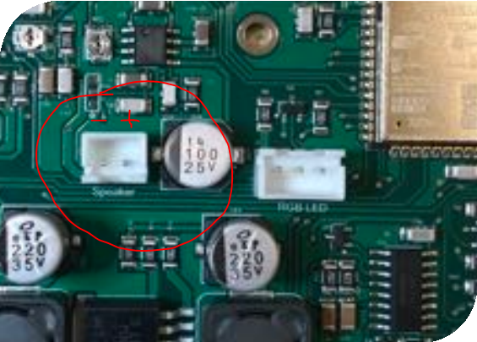

THIS IS CLEAR. OK HERE.

Figure 2: Headers for speaker

  - 2 pin header on the leS side of RGB LED header is to connect speakers. The positive end of the speaker will be connected to pin 1 (right side). Negative end will be connected to pin 2 (leS pin).

PROGRAMMER

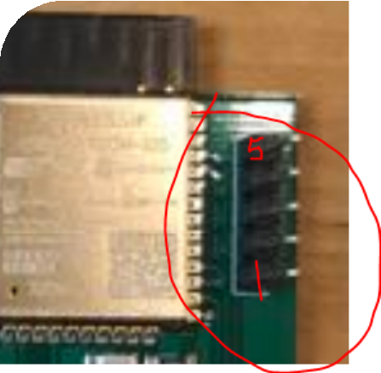
Figure 3: Programming headers

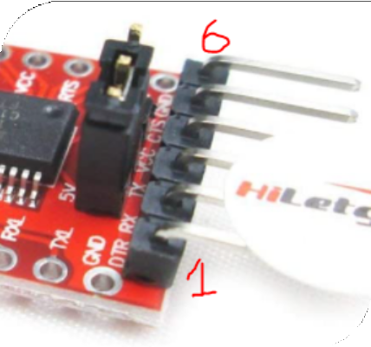

WAITING ABOUT PROGRAMMER HACK TO
BE ABLE TO UPLOAD CODE

Figure 4: USB to TTL serial converter

  - A black 5-pin male header, on the top right corner of the board, will be used to program the ESP 32 chip. Starting from the bottom, pin 1 is connected to RXD pin of the serial converter. Pin 2 of the male header should be connected to pin 3 of converter. Connect pin 4 of the header to pin 1 of converter. Pin 6 is GND and should be connected to pin 5 of the header.
•

RFIDs

THIS IS NOT CLEAR AT ALL FROM THE TEXTUAL DESCRIPTION (Already cleared)

RFID (Right to Left)
PCBA RFID RC522
Pin 1: Pin: 1 (3.3V)
Pin 2: Pin: 5 (MISO)
Pin 3: Pin: 6 (MOSI)
Pin 4: Pin: 7 (SCK)
Pin 5: Pin: 2 (RST)
Pin 6: Pin: 8 (SDA)
Pin 7: Pin: 3 (GND)
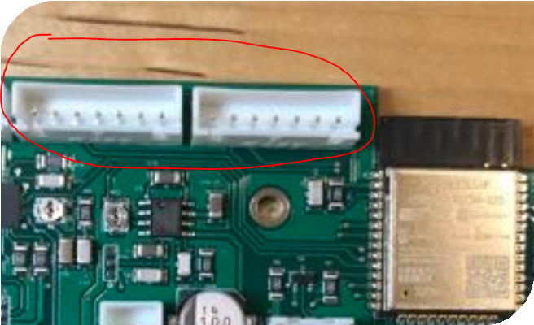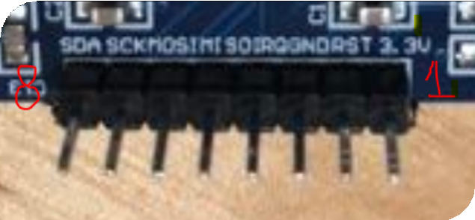
Figure 6: RFID module pinouts
Figure 5: Header for RFID module

  - On the top leS of ESP 32, the two 7-pin headers will be connected to RFID through female jumpers. Starting from the right corner, the ﬁrst pin needs to be connected to the 3.3V pin on the RFID board header. Connect the next 3 pins from right to leS to MISO, MOSI and SCK pins which are pin 6,7 and 8 of the module, respectively. 5th pin of the header will be connected to the second pin of the module. Connect pin 6 of the header to the second last pin of the module. The last pin of the header will be connected to the third pin of the RF module. Same scheme will be applied on the other RFID header.

BATTERY

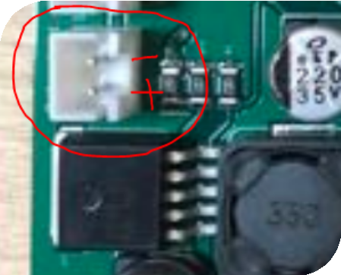
Figure 7: BaJery input header

THIS IS CLEAR. OK HERE.

  - The battery header is given at the right corner as shown in the picture. The RED wire should be connected to the positive terminal labeled in the ﬁgure whereas the BLACK wire will be connected to the negative terminal of the header.

NEXTION

NEXTION (YES)
PCBA Nextion
Pin 1: Color: Red (+5V)
Pin 2: Color: Blue. (TX)
Pin 3: Color: Yellow (RX)
Pin 4: Color: Black (GND)

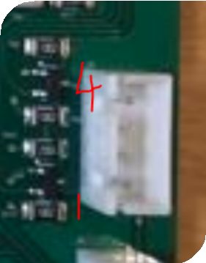
Figure 8: Header for Nextion screen

  - On the right corner, the 4 pin header is for nextion screen. As shown in the ﬁgure, pin 1 will be connected to the red wire of the LED. Similarly pin 2, 3, and 4 will be connected to wires blue, yellow and black respectively.

WEIGHT SENSOR (LOAD CELL)

WEIGHT SENSOR (YES)
PCBA Weight Sensor
Pin 1: Color: Green
Pin 2: Color: White.
Pin 3: Color: Black
Pin 4: Color: Red

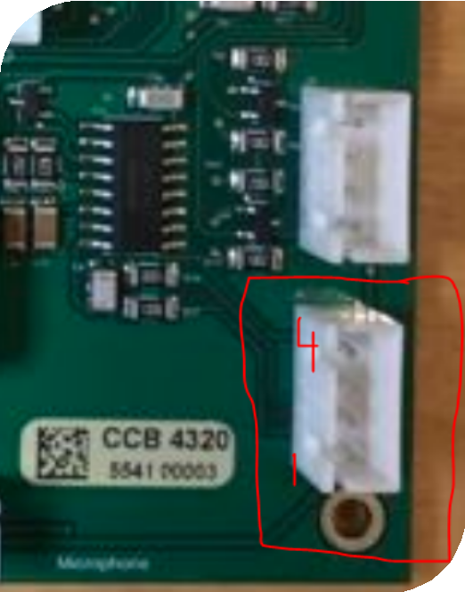

Figure 9: Header for weight sensor

  - Below the nextion screen header is the header to attach weight sensor. Connect pin one of the header to GREEN wire, pin 2 to WHITE wire, pin 3 to BLACK wire and pin 4 to RED one.

SERVO

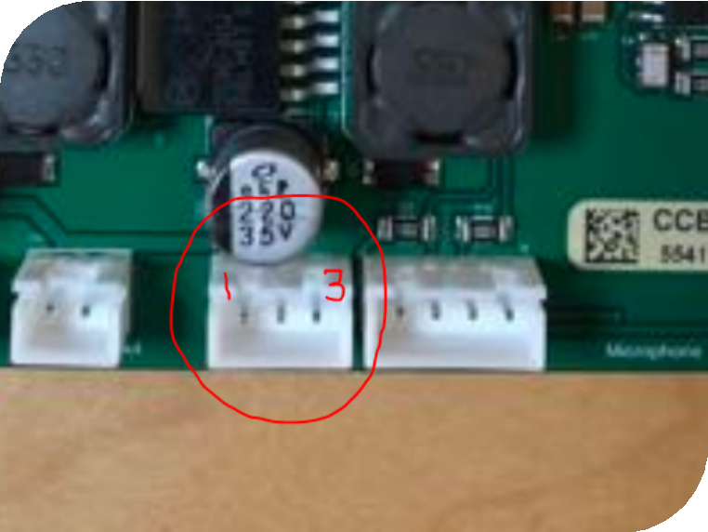

Figure 10: Headers for servo motor

  - The 3-pin header at the botton is given for servo motor. Connect the RED wire of servo to pin 1 of the header. The yellow and brown wire will be connected to pin 2 and 3 respectively.

SERVO (YES)
PCBA SERVO
Pin 1: Color: RED
Pin 2: Color: YELLOW.
Pin 3: Color: BROWN

- OPTICAL SENSOR

OPTICAL
PCBA OPTICAL SENSOR
Pin White: PIN # 2
Pin Red: PIN # 3
Pin Black: PIN # 4
Pin 4 (NC): PIN # 1 (NC)
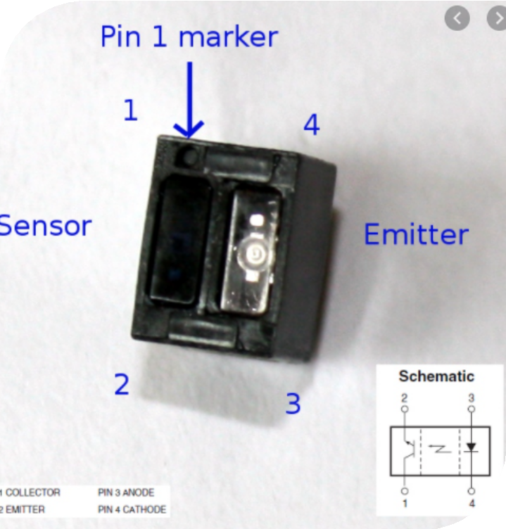
Figure 11: IR optical sensor pinouts

  - For optical sensor, the pin description is given above. Once you’ve identiﬁed pin 1 of the sensor with the help of the mark, connect it to pin 2 of the header.

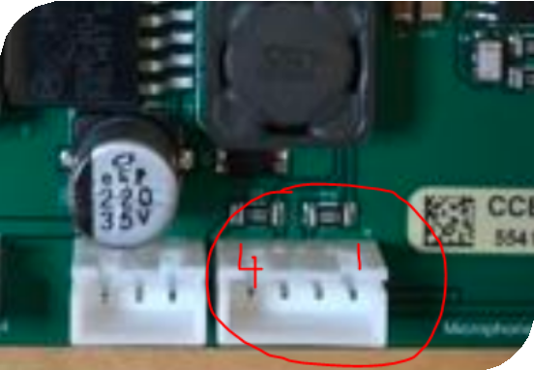
Figure 12: IR sensor Header

Pin 3 of the sensor will be attached to pin 3 of the header. The last two pins (pin 2 and 4) can be connected to pin and pin 4 of th header one by one.

BATTERY MANAGEMENT SYSTEM

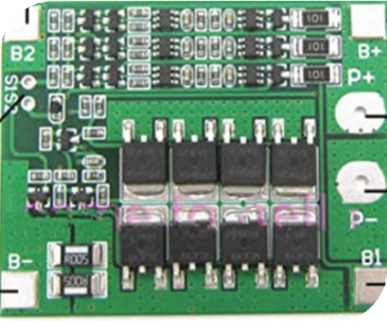
Figure 13: BaJery balancing PCB board

  - In the ﬁgure above, the battery balancing PCB board is given. The four corners of the board have the four connections that will be attached to the BMS balancing header on our circuit board via jumpers. The B+ terminal on the top right corner will be connected to pin 1 of the header. Similarly, B2 on the top leS corner will be connected to pin 2, B1 on bottom right to pin 3 and lastly, B- on the bottom leS to pin 4 of the BMS balancing header.

BMS (YES)
PCBA BMS
Pin 1: B+
Pin 2: B2
Pin 3: B1
Pin 4: B-

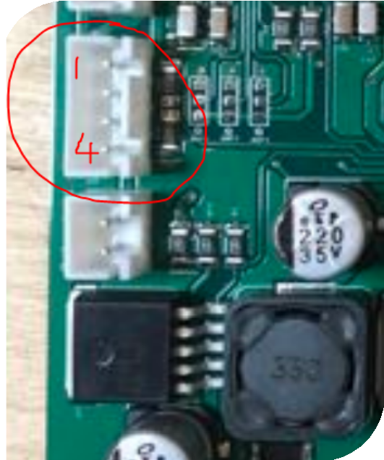

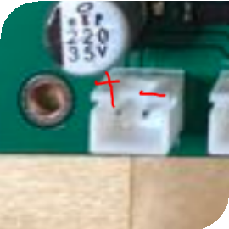
Figure 15: BMS output header
Figure 14: BMS balancing header

CLEAR ABOUT P+ AND P-
  - On the BMS PCB board there are two output terminals with marking P+ and P-. Connect P+ to the positively marked terminal of BMS output header.P- will go to the –ve pin of the header.

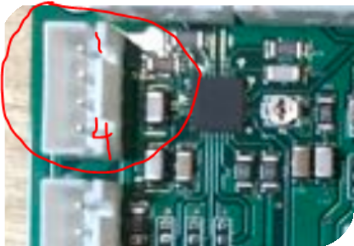BATTERY
Figure 16: BaJery balancing header

  - Above the BMS balancing header, a battery balancing header is provided. As shown in the ﬁgure above, connect the red wire to pin 1, the two yellow ones to pin 2 and 3 and black wire to the last pin of the header. PERFECT. THIS IS THE SAME ORDER FROM THE BATTERY ITSELF

STEPPER

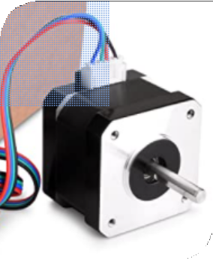
Figure 17: stepper motor

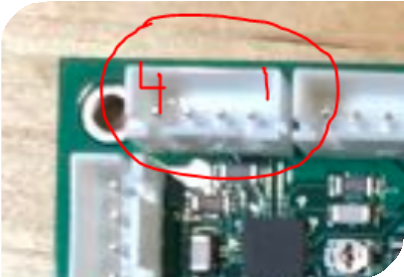
Figure 18: Header for stepper motor

STEPPER
PCBA STEPPER
Pin 1: BLACK
Pin 2: GREEN
Pin 3: RED
Pin 4: BLUE

  - From the ﬁgure of stepper motor, you can clearly see four wires for connections. The horizontal header on the top leS corner of the board is designated for stepper motor. Starting from right to leS, pin 1 and two will be connected to black and green wire whereas pin 3 and 4 will be connected to red and blue wire respectively.

DC JACK

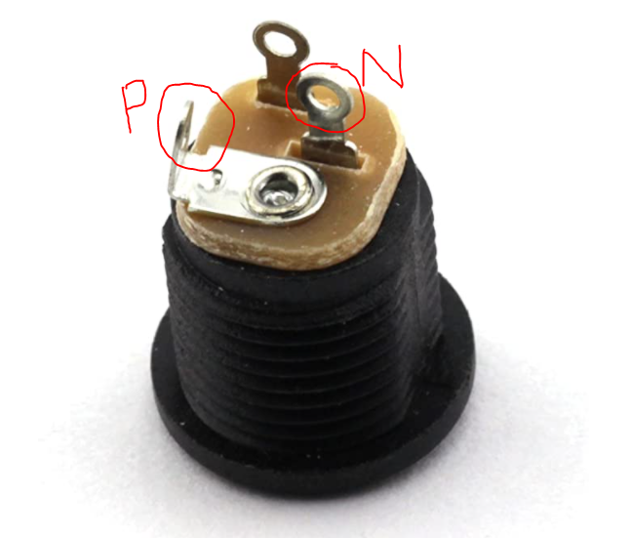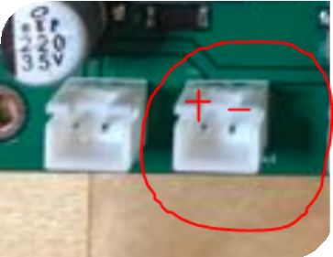

OK HERE.

  - From the ﬁgure above, identify the positive and negative terminals of your DC power jack and solder RED and BLACK wire to the respective terminal. Now connect these two wires accordingly to the positive and negative terminal of the charging header following the ﬁgure given above.

